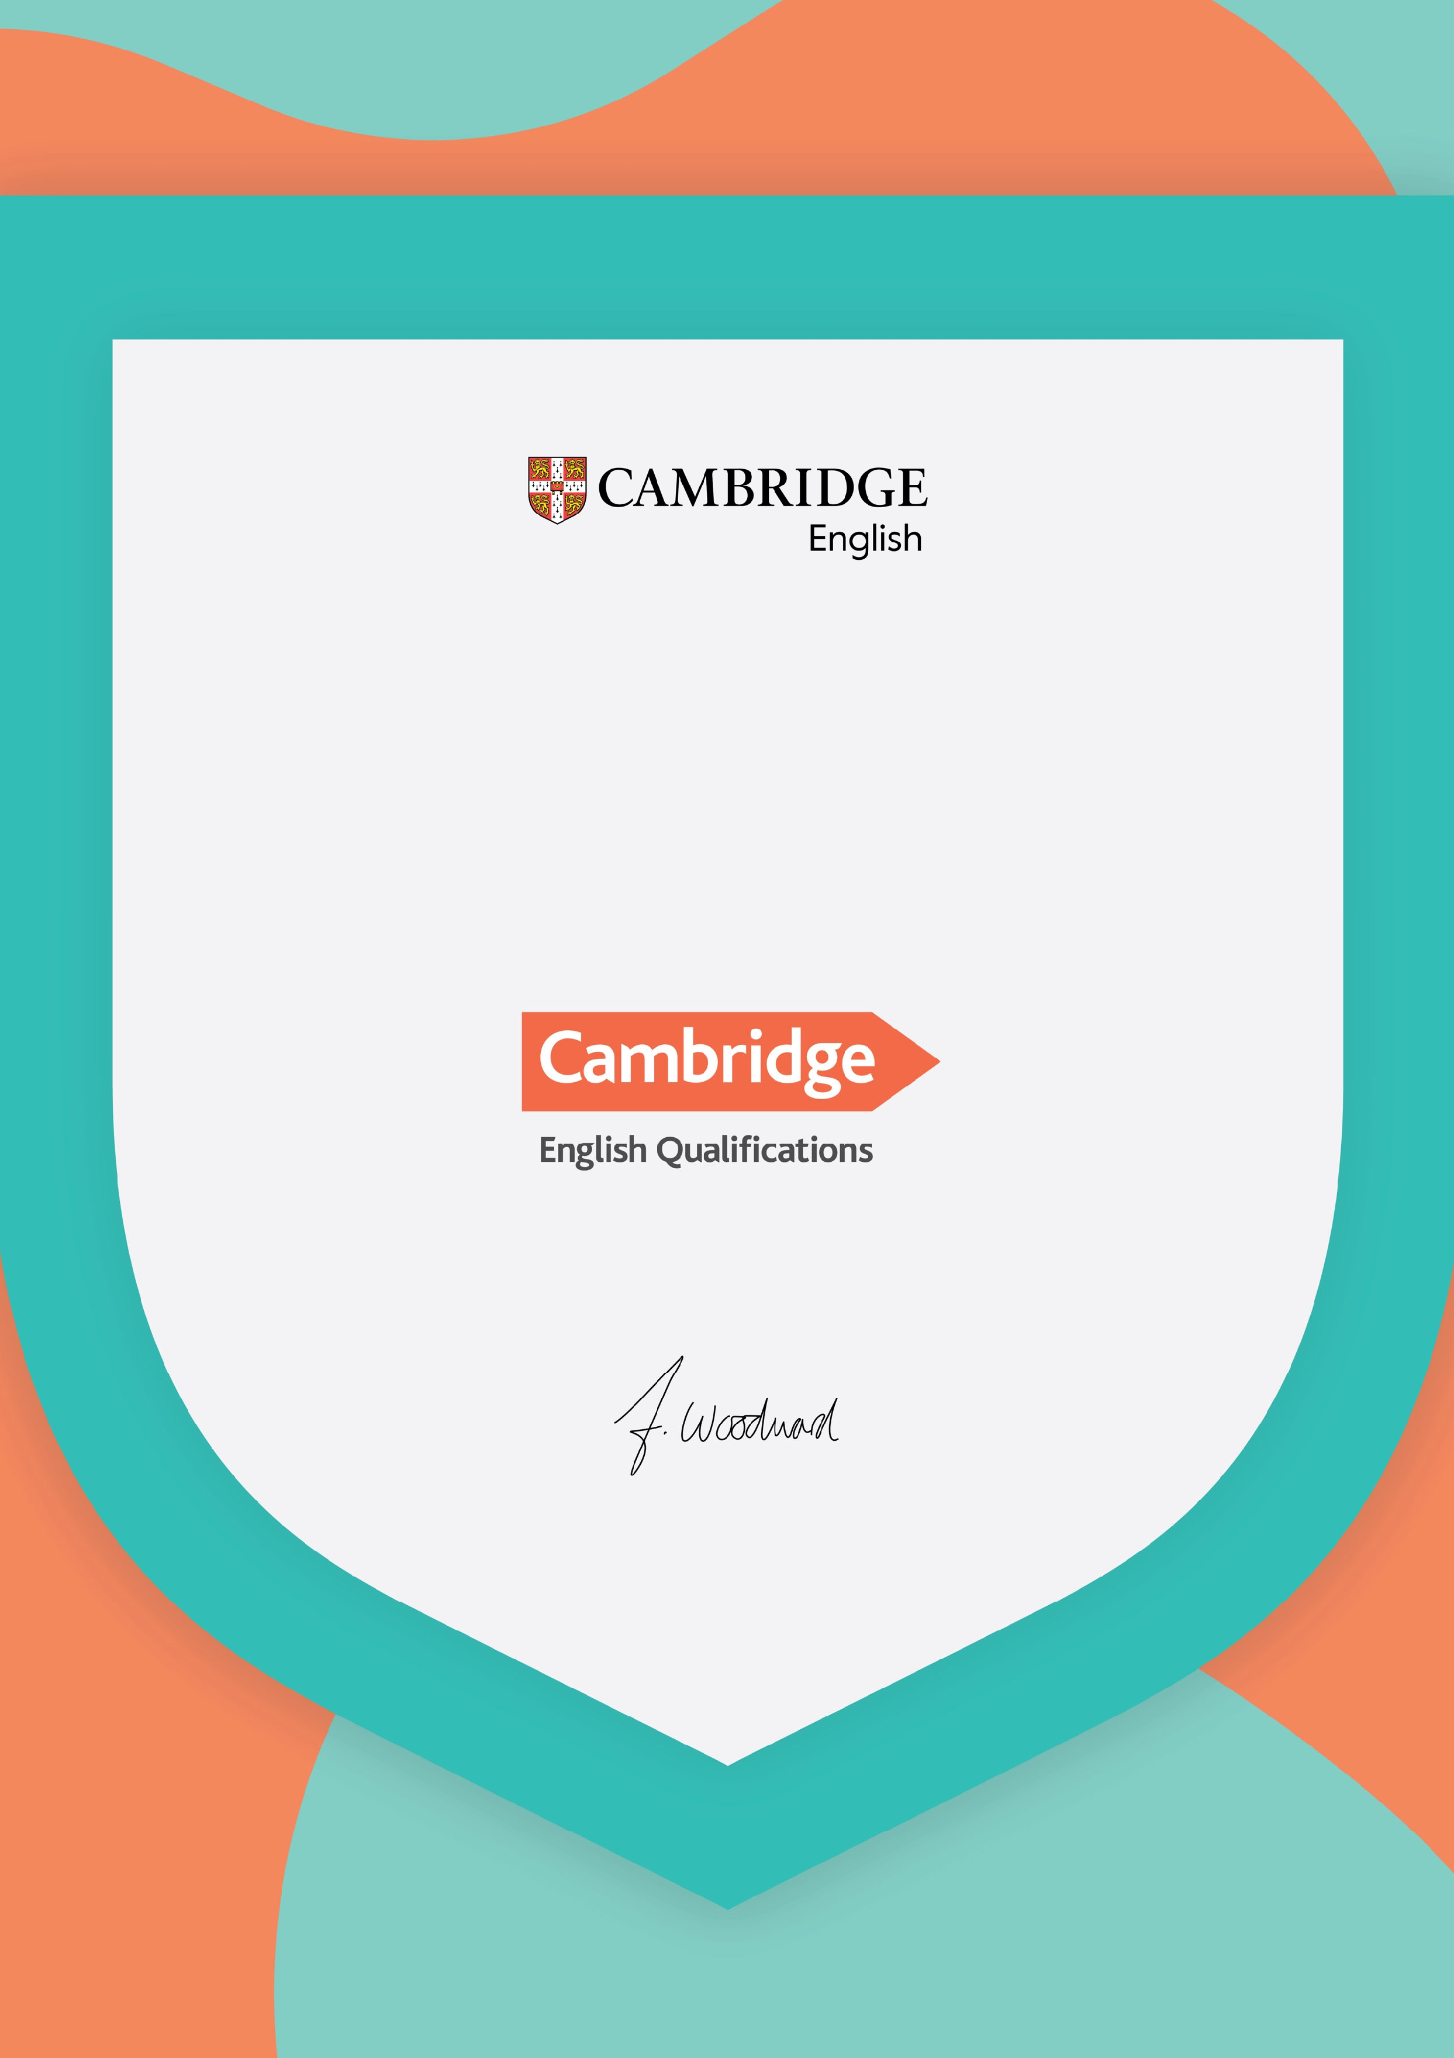

This is to certify that

Veluws College Walterbosch
APELDOORN

is a preparation centre that prepares learners for:

From: 08/2023 To: 07/2024

Francesca Woodward Global Managing Director, English
Cambridge University Press & Assessment
Issued on: 17/10/2023

This certificate is the property of Cambridge English and must be returned on request. lt must be displayed at the main address of the preparation centre.

This certificate must not be copied or reproduced in any format without our express written permission.
A photograph of the certificate may be displayed on your website or social media channels.

Any enquiries regarding the authenticity of this certificate should be directed to: Cambridge English Brand Team, Shaftesbury Road, Cambridge, CB2 8EA, United Kingdom

Email: English.brand@cambridge.org

© 2023 Cambridge University Press & Assessment

